Assignment 1

Ans1. The difference between UI and UX is as UI is a tool which is used to add images, text files, drop-downs, etc whereas UX fully depends on user experience if the user is comfortable with my UI or not I have used UI added the drop-down box if the colour of drop-down box is red then users is not comfortable from it if green it improves visibility and user is more comfortable while using it.

Ans2. Front end developer is the developer who has to deal with the user interaction they don’t have to bother about how to fetch data and how data can be got through it. our main focus is to usually deal with UI and UX. I have a front end that can be developed by HTML itself. Front end developer works on HTML, CSS, Node JS, etc.

Ans 3. Back end developers are the developer that has to deal with how the data is processed in the server what is the output generated by it and how can we give our data so that it is error-free and enhanced the user experience. The Back end developer should love to use databases as most of the chuck of time is always going into the database. They mainly focus on logical implementations.

Ans 4. The screen shot of github

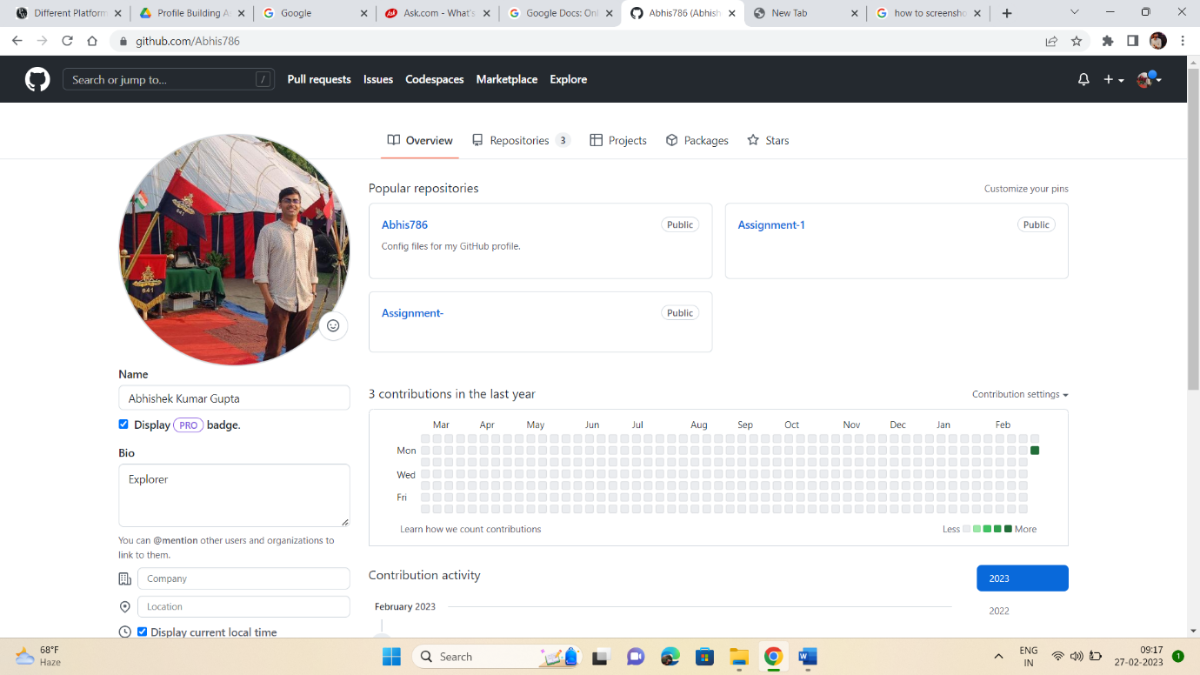

<https://github.com/Abhis786>

LinkedIn Profile screen shot



<https://www.linkedin.com/in/abhishek-kumar-gupta-a8257a206/>

Ans 5. <https://qualitywala.hashnode.dev/section-230>